URL_Shortener

This python application is developed to convert long URLs to short encoded URL which will redirect the user to original entered URL.

# Steps to execute application

* Execute main.py in cmd based interface having python installed on it.
* Command : python main.py
* Open your web browser and go to http://127.0.0.1:5000 where python application is hosted by Flask.
* Enter the address of web URL for which you want to create short URL.
* Press Submit button.
* Result is displayed on the webpage.
* Click on the displayed short web URL which will redirect to original long URL.
* End of script.

# Making Application Scalable

* To make this application highly scalable we can use Kafka to help in maintaining multiple requests, global counter and to synchronize each application to prevent any kind of collision or redundant data into database.
* Below is the architectural diagram of the proposed application:

NoSQL/RDBMS Database

Conversion Server 1

 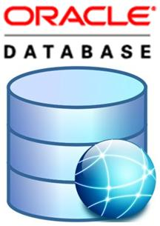

Conversion Server 3

Conversion Server 2

Load Balancer



|  |
| --- |
| 1 – 1 Lakh Counter value |
| 1 – 2 Lakh Counter value |
| 2 – 3 Lakh Counter value |
| 3 – 4 Lakh Counter value |
| 4 – 5 Lakh Counter value |

ZooKeeper